HABITS OF A MULTIPLYING DISCIPLE: MULTIPLY

HOMEWORK DISCUSSION
What stood out to you in your study of Mark 1:16-20?

Discuss the plans you wrote out as part of your assignment.
- Who are you called to reach?
- Who is or might be on your team for reaching them?
- What is your plan for the next 3 months? What will you do in the next 48 hours?

How can you multiply all the habits in the months ahead?

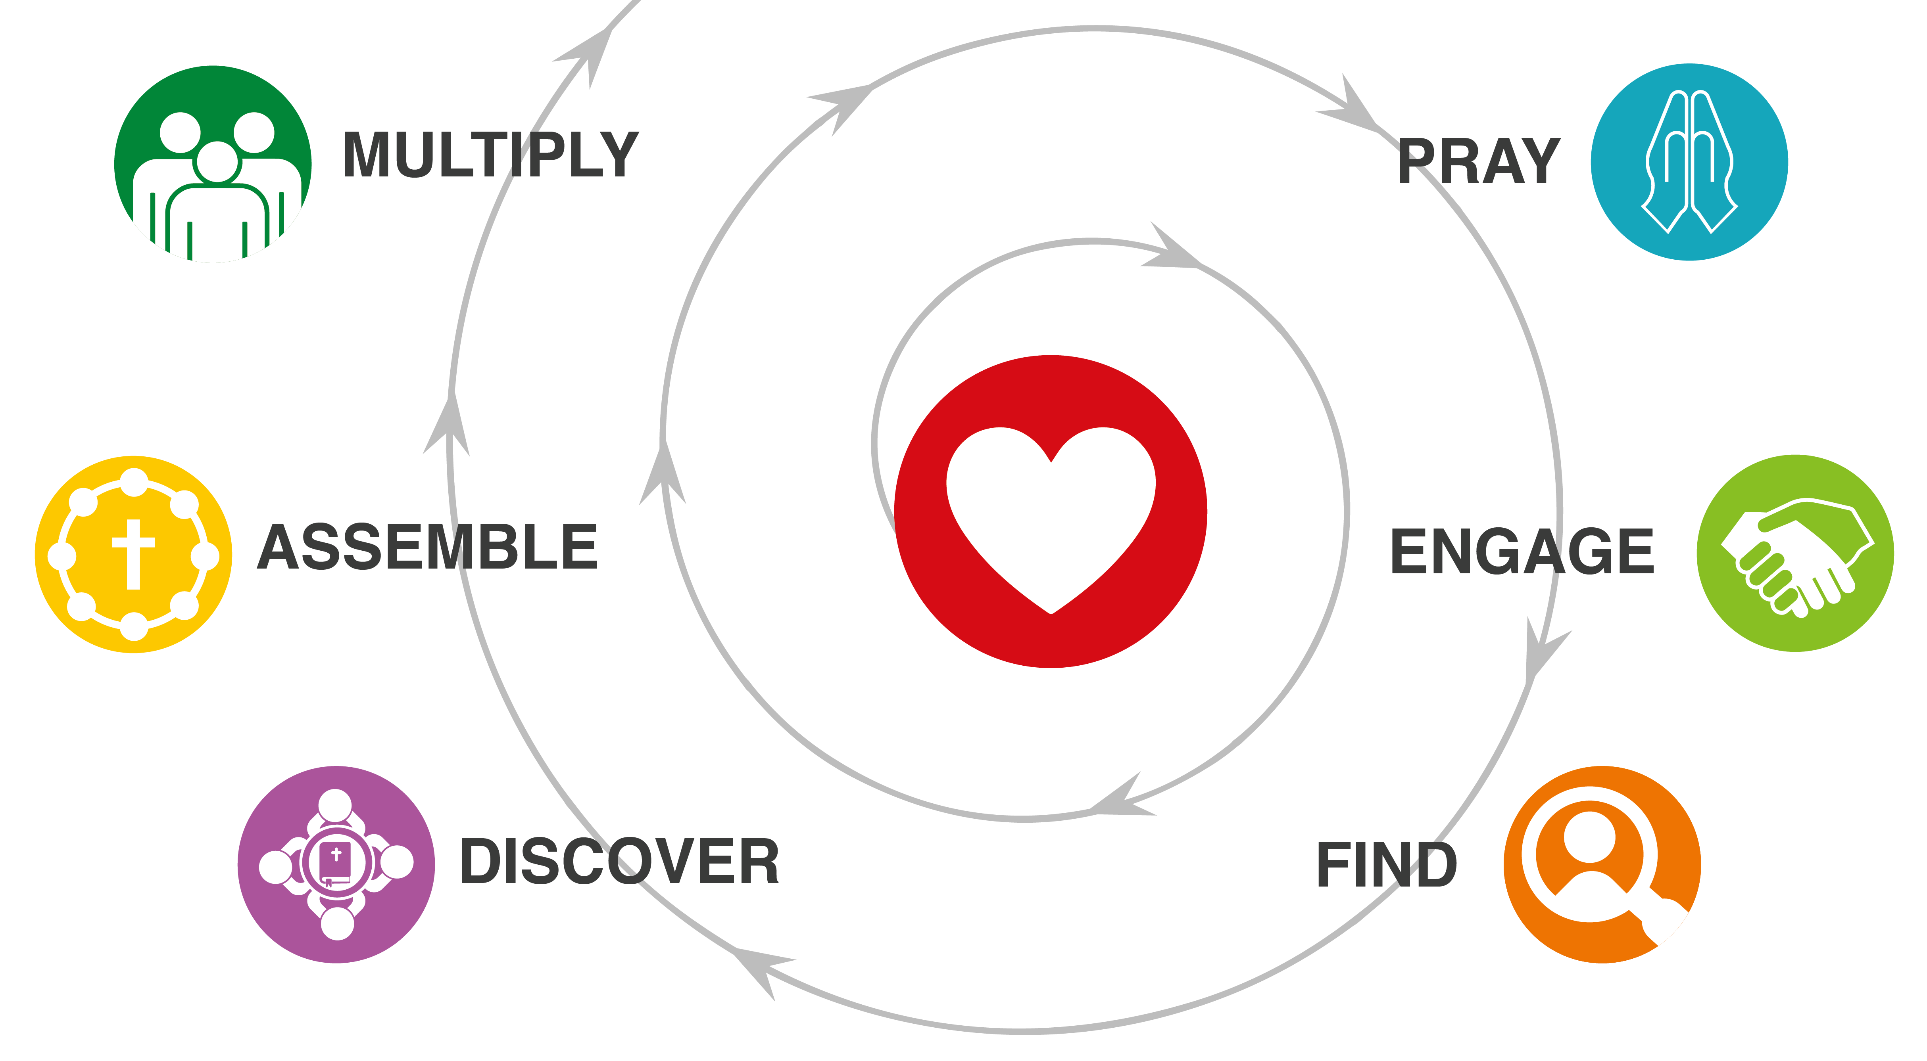
DISCIPLE MAKING MOVEMENT ARE LEADERSHIP MOVEMENTS: TRUE OR FALSE?
We need to multiply at every level!

How can you multiply all the habits?

Apply 2 Timothy 2:2:
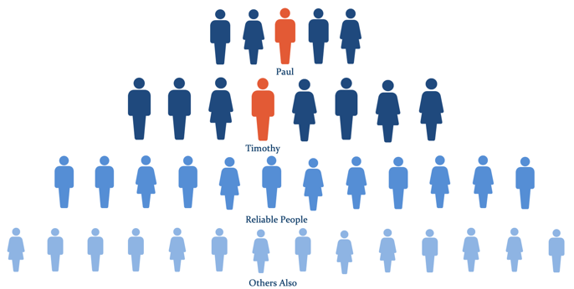
And the things you have heard me say in the presence of many witnesses entrust to reliable people who will also be qualified to teach others.

WHAT IS NEXT?
What were your most important learnings from this training?
We all need a peer group for encouragement, prayer, and ongoing learning.

YOUR ASSIGNMENT: GO MAKE DISCIPLES!
- Go and make disciple makers! Catalyze Disciple Making Movements among Unreached People Groups.
- Be patient and keep learning. Jesus says that exponential growth takes time and begins in very small ways. (Matthew 13:31-33)
- Sign up for coaching and find resources at disciplemakingmovements.com.
- Help improve this training by taking a 2-minute survey at: https://forms.gle/fUcqo7q71hQUZGPi8.

